|  |  |  |  |  |  |  |
| --- | --- | --- | --- | --- | --- | --- |
| Sun | Mon | Tue | Wed | Thu | Fri | Sat |
|  | 1 | 2 | 3 | 4 | 5 | 6 |
| 7 | 8 | 9 | 10 | 11 | 12 | 13 |
| 14 | 15 | 16 | 17 | 18 | 19 | 20 |
| 21 | 22 | 23 | 24 | 25 | 26 | 27 |
| 28 | 29 | 30 | 31 |  |  |  |

・11月3日　文化の日

・11月23日 勤労感謝の日

・11月24日 振替休日

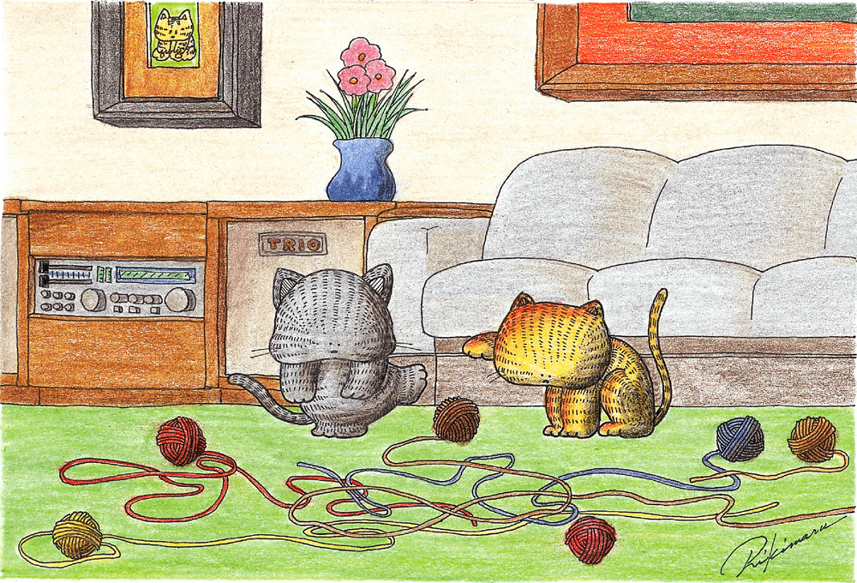

|  |  |  |  |  |  |  |  |  |  |  |  |  |  |  |  |  |  |  |  |  |  |  |  |  |  |  |  |  |  |
| --- | --- | --- | --- | --- | --- | --- | --- | --- | --- | --- | --- | --- | --- | --- | --- | --- | --- | --- | --- | --- | --- | --- | --- | --- | --- | --- | --- | --- | --- |
| **土** | **日** | **月** | **火** | **水** | **木** | **金** | **土** | **日** | **月** | **火** | **水** | **木** | **金** | **土** | **日** | **月** | **火** | **水** | **木** | **金** | **土** | **日** | **月** | **火** | **水** | **木** | **金** | **土** | **日** |
| **1** | **2** | **3** | **4** | **5** | **6** | **7** | **8** | **9** | **10** | **11** | **12** | **13** | **14** | **15** | **16** | **17** | **18** | **19** | **20** | **21** | **22** | **23** | **24** | **25** | **26** | **27** | **28** | **29** | **30** |