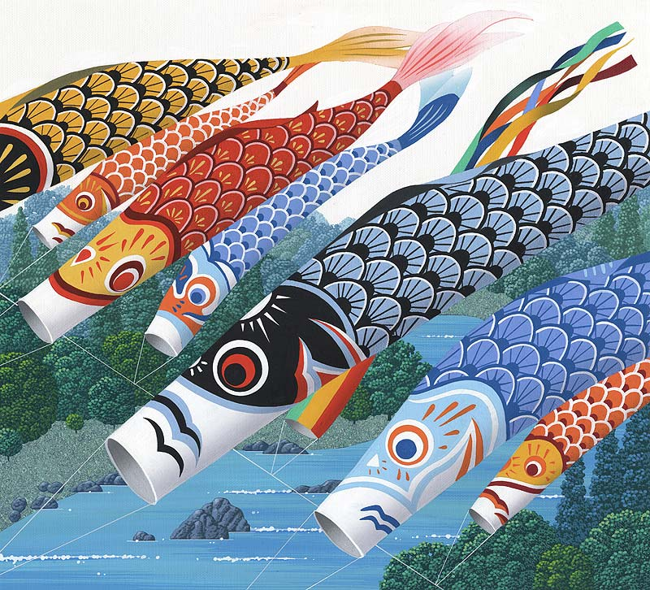

|  |  |  |  |  |  |  |
| --- | --- | --- | --- | --- | --- | --- |
| Sun | Mon | Tue | Wed | Thu | Fri | Sat |
|  |  |  |  |  |  | 1 |
| 2 | 3 | 4 | 5 | 6 | 7 | 8 |
| 9 | 10 | 11 | 12 | 13 | 14 | 15 |
| 16 | 17 | 18 | 19 | 20 | 21 | 22 |
| 23 | 24 | 25 | 26 | 27 | 28 | 29 |
| 30 |  |  |  |  |  |  |

* **5月3日　憲法記念日**
* **5月4日　みどり日**
* **5月5日　こどもの日**
* **5月6日　振替休日**



|  |  |  |  |  |  |  |  |  |  |  |  |  |  |  |  |  |  |  |  |  |  |  |  |  |  |  |  |  |  |  |
| --- | --- | --- | --- | --- | --- | --- | --- | --- | --- | --- | --- | --- | --- | --- | --- | --- | --- | --- | --- | --- | --- | --- | --- | --- | --- | --- | --- | --- | --- | --- |
| **水** | **木** | **金** | **土** | **日** | **月** | **火** | **水** | **木** | **金** | **土** | **日** | **月** | **火** | **水** | **木** | **金** | **土** | **日** | **月** | **火** | **水** | **木** | **金** | **土** | **日** | **月** | **火** | **水** | **木** | **金** |
| **1** | **2** | **3** | **4** | **5** | **6** | **7** | **8** | **9** | **10** | **11** | **12** | **13** | **14** | **15** | **16** | **17** | **18** | **19** | **20** | **21** | **22** | **23** | **24** | **25** | **26** | **27** | **28** | **29** | **30** | **31** |